**NAME:** SREYA G **REGISTER NO.:** 230701334

**CLASS :** CSE F **DATE:** 10/09/2024

**EX – 5:**

**DYNAMIC PROGRAMMING:**

PROBLEM 1:

AIM:

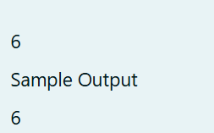

ALGORITM:

1. Input n:

- Read the integer n from the user.

2. Initialize an array dp:

- Create an array dp of size n + 1.

- Set dp[0] = 1, dp[1] = 1, dp[2] = 1, and dp[3] = 2.

3. Calculate values for dp[i] (for i = 4 to n):

- Use the formula:

- dp[i] = dp[i - 1] + dp[i - 3].

4. Return dp[n]:

- The value at dp[n] gives the result.

5. Output the result:

- Print the value returned by the function ways(n).

6. End.

CODE:

#include<stdio.h>

long long ways(int n){

long long dp[n + 1];

dp[0] = 1;

dp[1] = 1;

dp[2] = 1;

dp[3] = 2;

int i;

for(i = 4;i <= n;i++){

dp[i] = dp[i - 1] + dp[i - 3];

}

return dp[n];

}

int main(){

int n;

scanf("%d",&n);

printf("%lld\n",ways(n));

return 0;

}

OUTPUT:

RESULT:

Thus the code is executed successfully and gives the expected output.

PROBLEM 2:

AIM:

ALGORITHM:

1. Input n.

2. Initialize a 2D array cb[n][n] and read its values.

3. Initialize a 2D array dp[n][n] with dp[0][0] = cb[0][0].

4. Fill the first row and column of dp using the values from cb.

5. For each i and j, update dp[i][j] as the maximum sum from the top or left cell.

6. Output dp[n-1][n-1].

7. End.

CODE:

#include<stdio.h>

int main(){

int n;

scanf("%d",&n);

int cb[n][n];

int i,j;

for(i = 0;i < n;i++){

for(j = 0;j < n;j++){

scanf("%d",&cb[i][j]);

}

}

int dp[n][n];

dp[0][0] = cb[0][0];

for(i = 1;i < n;i++){

dp[i][0] = dp[i - 1][0] + cb[i][0];

dp[0][i] = dp[0][i - 1] + cb[0][i];

}

for(i = 1;i < n;i++){

for(j = 1;j < n;j++){

if(dp[i - 1][j] > dp[i][j - 1]){

dp[i][j] = cb[i][j] + dp[i - 1][j];

}else{

dp[i][j] = cb[i][j] + dp[i][j -1];

}

}

}

printf("%d\n",dp[n - 1][n - 1]);

return 0;

}

OUTPUT:

RESULT:

Thus the code is executed successfully and gives the expected output.

PROBLEM 3:

AIM:

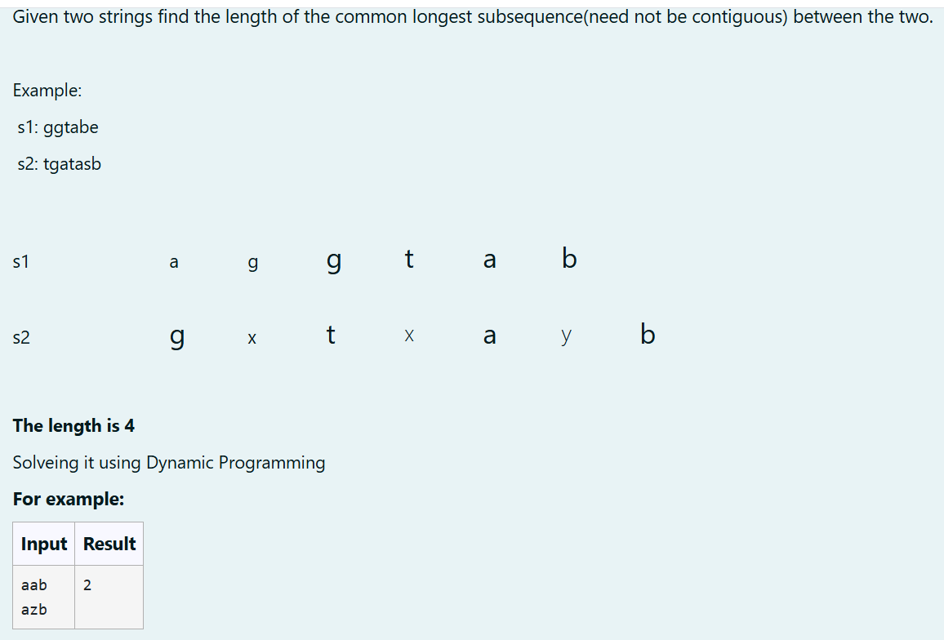

ALGORITHM:

1. Input strings s1 and s2.

2. Initialize m = length of s1 and n = length of s2, and create a 2D array dp[m+1][n+1].

3. Set base cases: dp[i][0] = 0 and dp[0][j] = 0.

4. For each i and j, if s1[i-1] == s2[j-1], set dp[i][j] = dp[i-1][j-1] + 1; else, set dp[i][j] = max(dp[i-1][j], dp[i][j-1]).

5. Return dp[m][n] as the LCS length.

6. Output the result.

CODE:

#include<stdio.h>

#include<string.h>

int clsLen(char * s1,char * s2){

int m = strlen(s1);

int n = strlen(s2);

int dp[m + 1][n + 1];

int i,j;

for(i = 0;i <= m;i++){

for(j = 0;j <= n;j++){

if(i == 0 ||j == 0){

dp[i][j] = 0;

}else{

if(s1[i - 1] == s2[j - 1]){

dp[i][j] = dp[i - 1][j - 1] + 1;

}else{

if(dp[i - 1][j] > dp[i][j - 1]){

dp[i][j] = dp[i - 1][j];

}else{

dp[i][j] = dp[i][j - 1];

}

}

}

}

}

return dp[m][n];

}

int main(){

char s1[100],s2[100];

scanf("%s",s1);

scanf("%s",s2);

int answer = clsLen(s1,s2);

printf("%d\n",answer);

return 0;

}

OUTPUT:

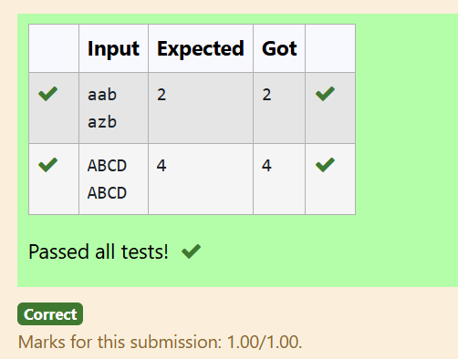

RESULT:

Thus the code is executed successfully and gives the expected output.

PROBLEM 4:

AIM:

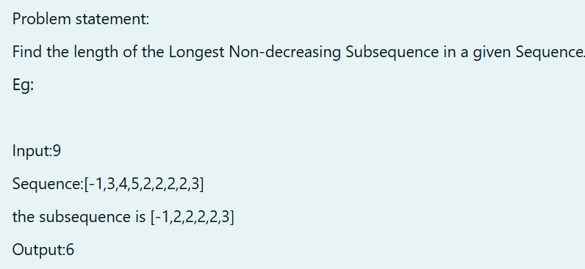

ALGORITHM:

1. Input array arr[] and size n.

2. Initialize a DP array dp[] with all values set to 1.

3. For each element `i` from 1 to n-1, and for each element `j` from 0 to `i-1`:

- If `arr[i] >= arr[j]`, update `dp[i] = max(dp[i], dp[j] + 1)`.

4. Find the maximum value in `dp[]` to get the length of the longest non-decreasing subsequence.

5. Output the result.

CODE:

#include<stdio.h>

int lonNonDecSubseq(int arr[],int n){

int dp[n];

int i,j,maxlen = 1;

for(i = 0;i < n;i++){

dp[i] = 1;

}

for(i = 1;i < n;i++){

for(j = 0;j < i;j++){

if(arr[i] >= arr[j]){

if(dp[i] < dp[j] + 1){

dp[i] = dp[j] + 1;

}

}

}

}

for(i = 0;i < n;i++){

if(dp[i] > maxlen){

maxlen = dp[i];

}

}

return maxlen;

}

int main(){

int arr[] = {-1,3,4,5,2,2,2,2,3};

int n = sizeof(arr) / sizeof(arr[0]);

int answer = lonNonDecSubseq(arr,n);

printf("%d\n",answer);

return 0;

}

OUTPUT:

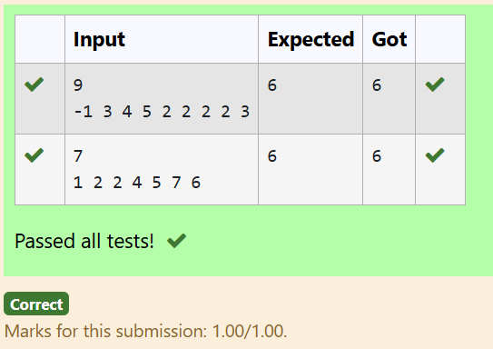

RESULT:

Thus the code is executed successfully and gives the expected output.